**USABILITY REPORT**

**Introduction**

Usability simply means make app, website, pages or any human interaction UI user friendly for all kind of user from old to young and from physically fit to disable people all around the world.

[**https://www.sciencedirect.com/science/article/pii/S2352340923010077**](https://www.sciencedirect.com/science/article/pii/S2352340923010077)

**Literature Review**

**How to Develop Information Systems to Improve**

**Accessible Tourism: Proposal of a Roadmap to**

**Support Development of Accessible Solutions**

[**https://www.mdpi.com/2073-431X/13/3/69**](https://www.mdpi.com/2073-431X/13/3/69)

This author of this report is MDPI, Basel, Switzerland. This article is an open access article distributed under the term and conditions of the creative commons

Attribution (CCBY) license <https://creativecommons.org/licenses/by/4.0/>

This report is all about making tourism information and service through website or app better for every kind of tourist from all around the world from different nationality, language, and continents.

**Alternative Forms of Tourism : A comparative Study of Website Effectiveness in Promoting UNESCO Global Geoparks and International Dark Sky Parks**

[**https://www.mdpi.com/2071-1050/16/2/864**](https://www.mdpi.com/2071-1050/16/2/864)

This author of this report is MDPI, Basel, Switzerland. This article is an open access article distributed under the term and conditions of the creative commons

Attribution (CCBY) license

[**https://creativecommons.org/licenses/by/4.0/**](https://creativecommons.org/licenses/by/4.0/)

This report is all about making National, Geo park information and service through websites or apps better for every kind of tourist from all around the world from different nationalities, languages, and continents.

**Analysis**

1. [**https://ntb.gov.np/**](https://ntb.gov.np/)
2. [**https://dnpwc.gov.np/en/**](https://dnpwc.gov.np/en/)
3. [**https://ntb.gov.np/**](https://ntb.gov.np/) **:**

“Schneider man’s 8 golden rules”

1. Strive for consistency

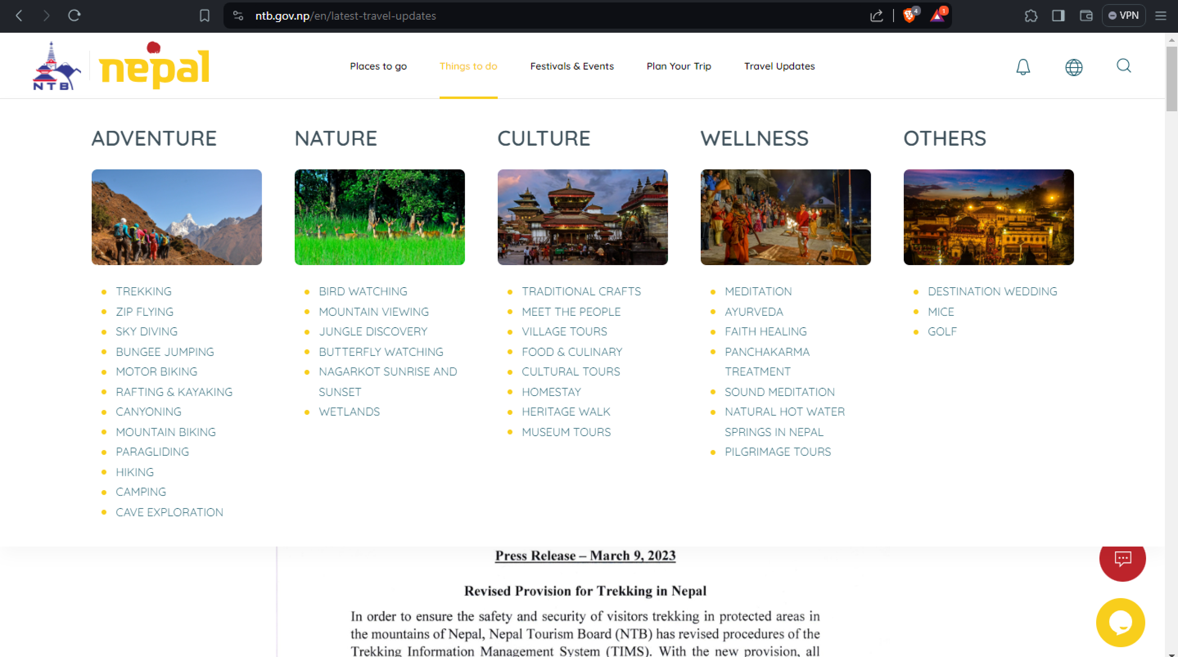

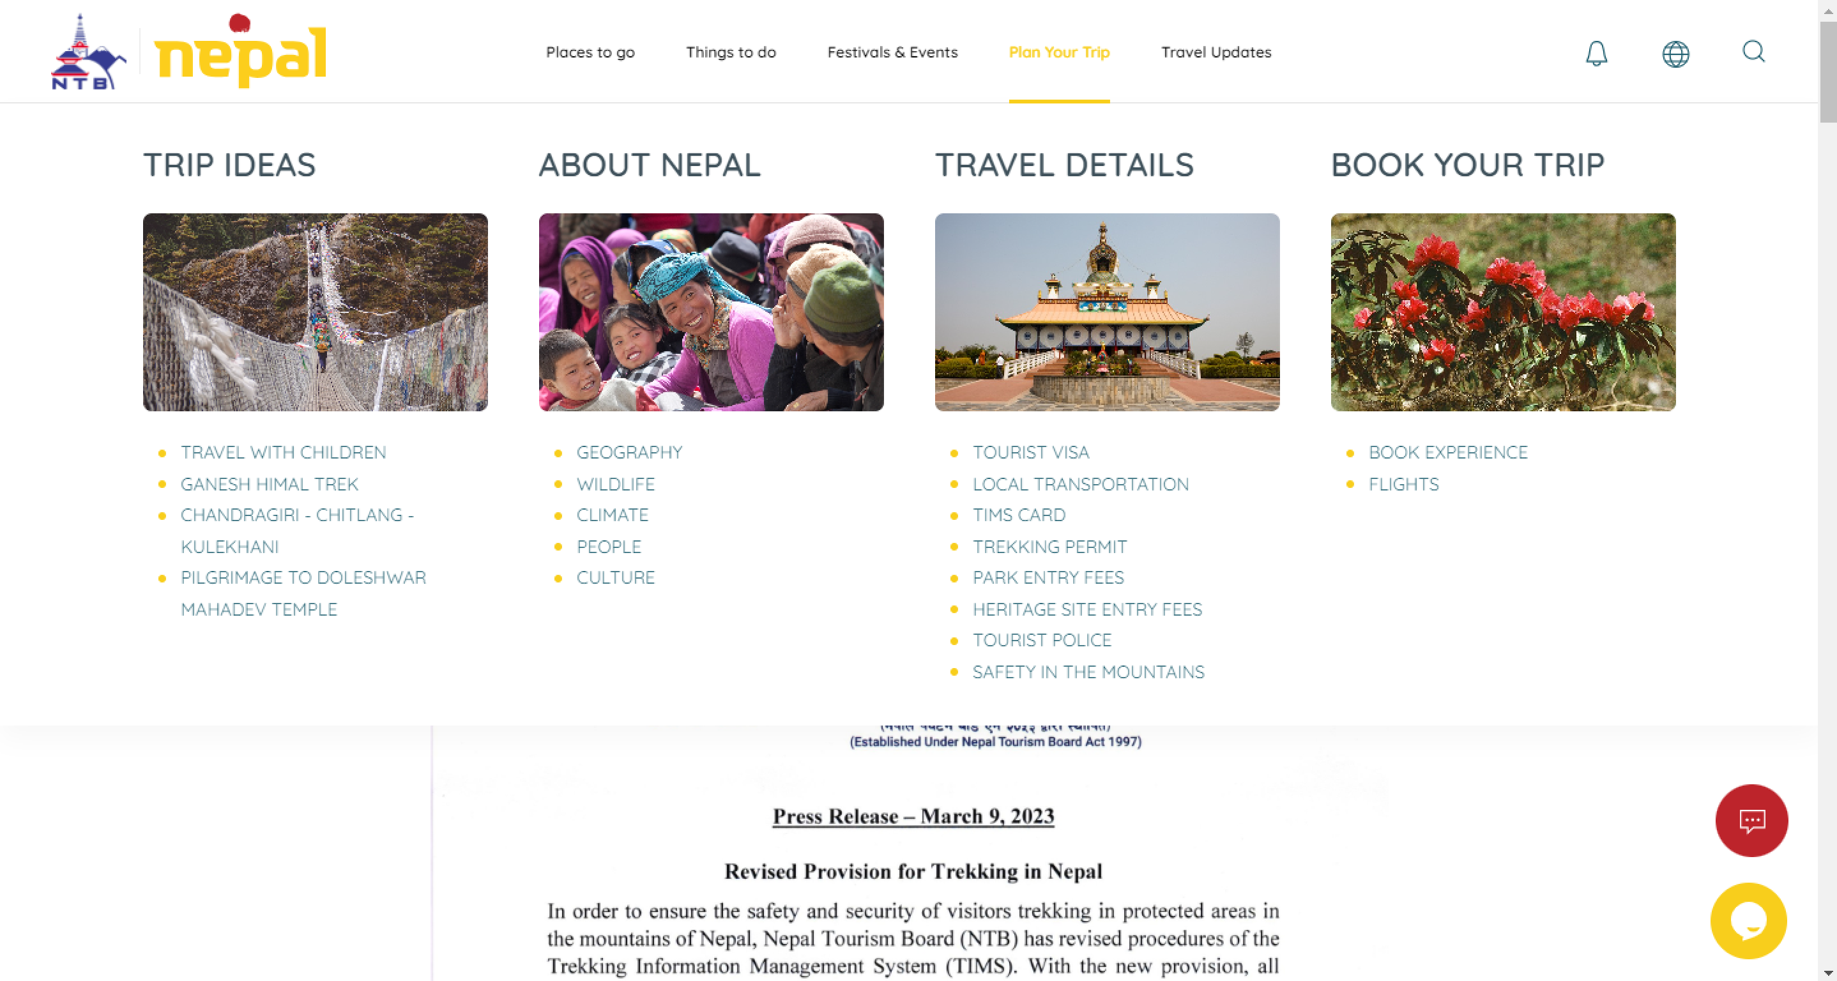

1. Enable frequent users to use shortcuts

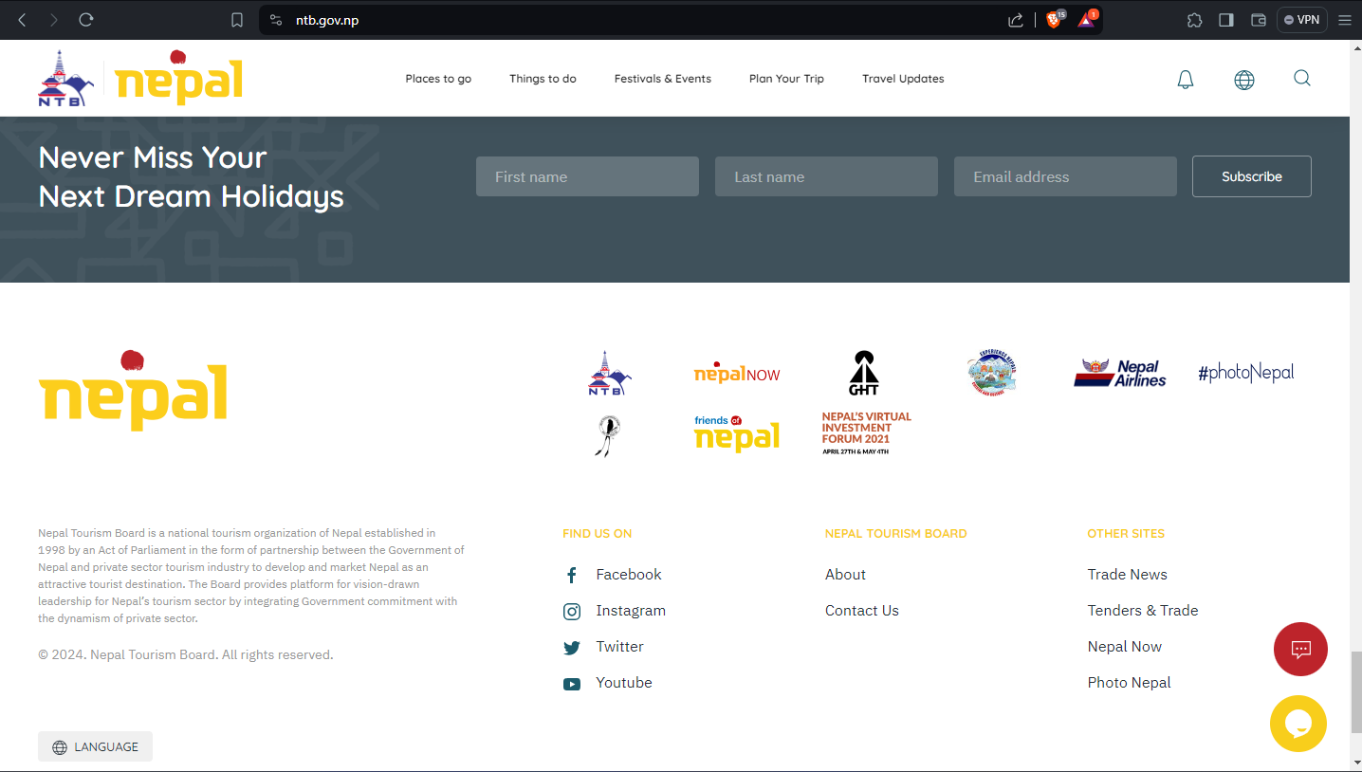

1. Offer informative Feedback

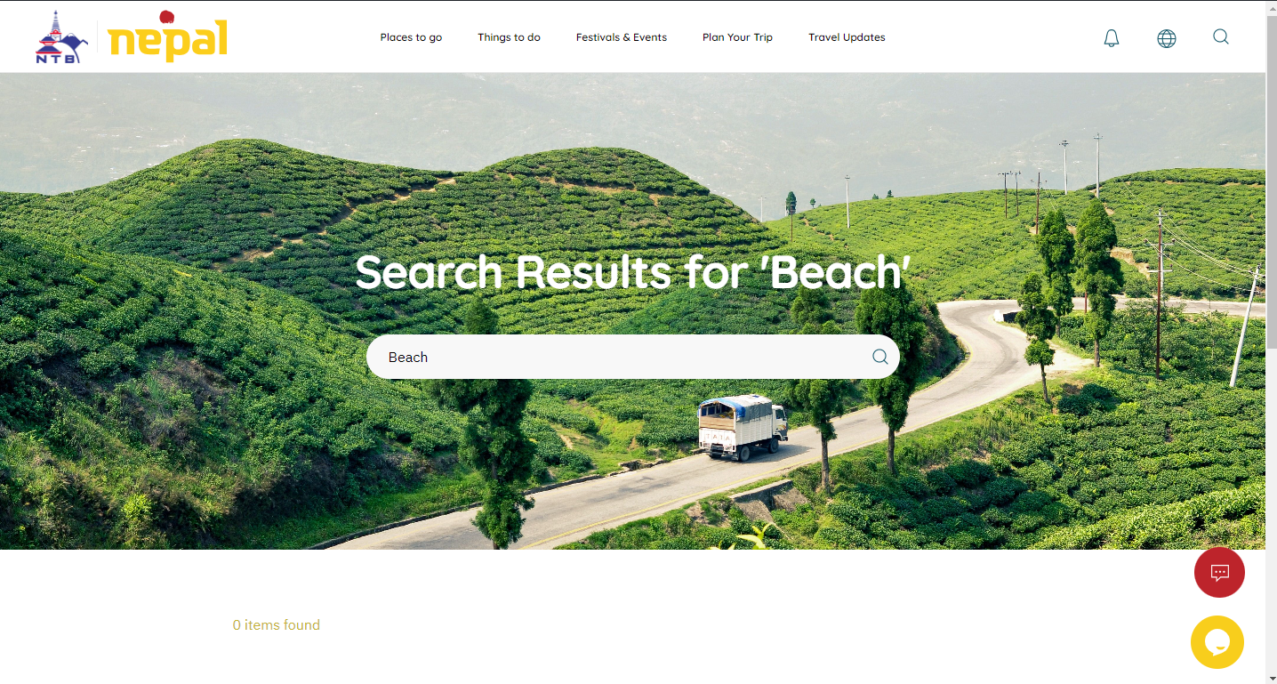

1. Design dialog to yield closure

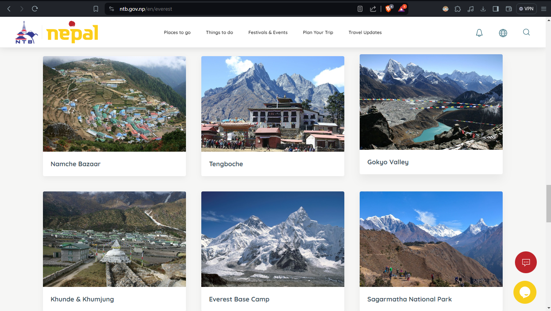

1. Offer simple error handling

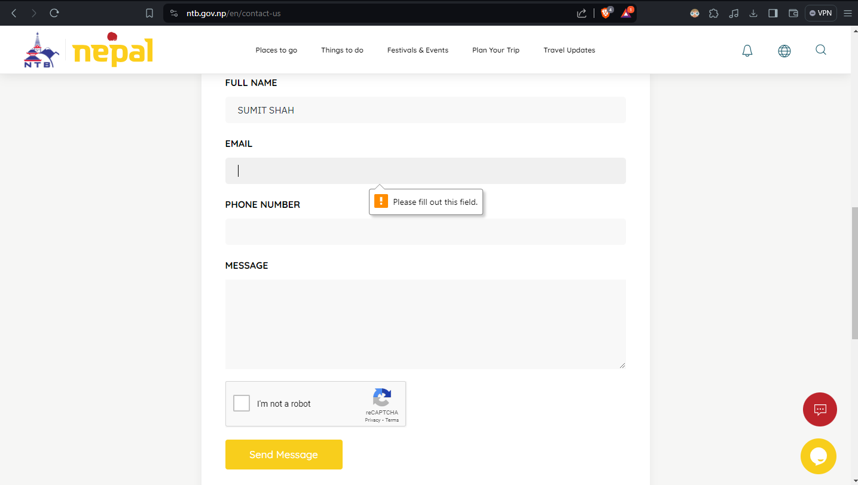

1. Permit easy reversal of actions

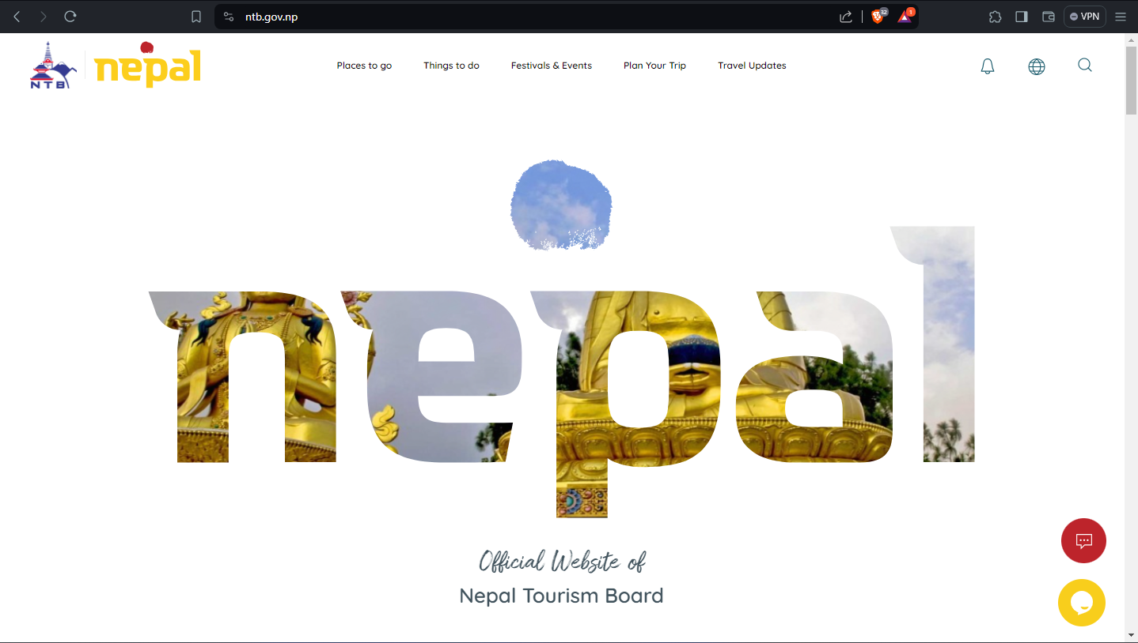

1. Support internal locus of control

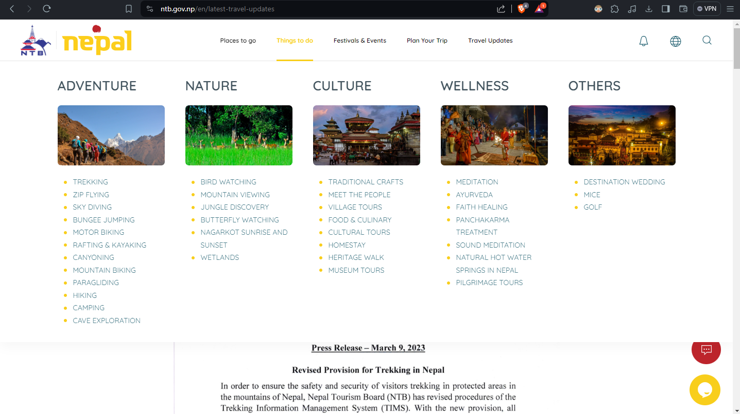

1. Reduce short-term memory load



“Nielson’s Usability Heuristics”

1. Visibility of system status

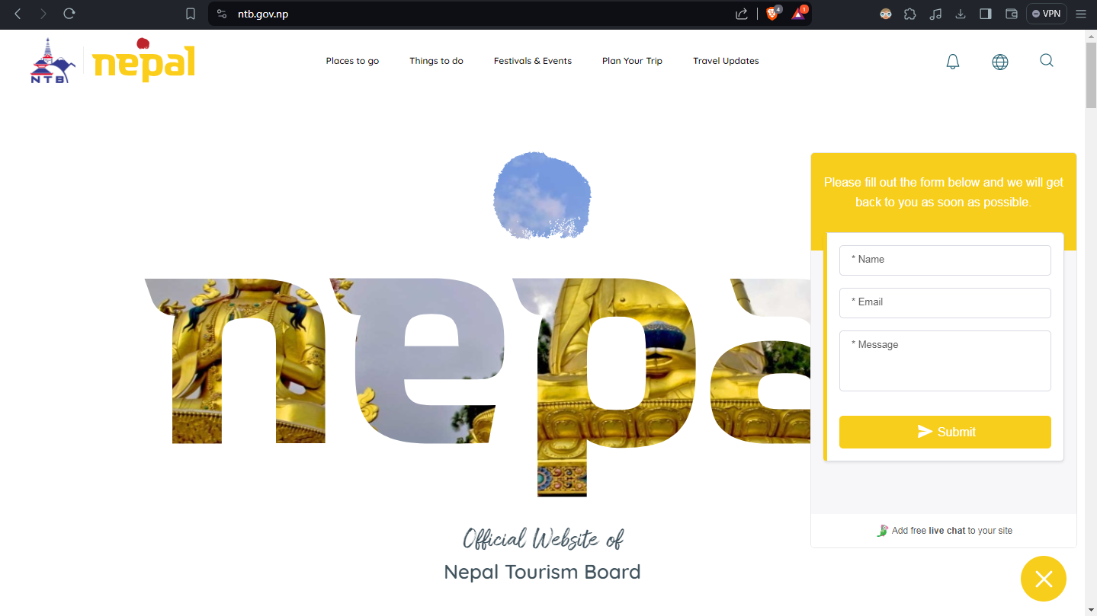

1. Match between system and the real world

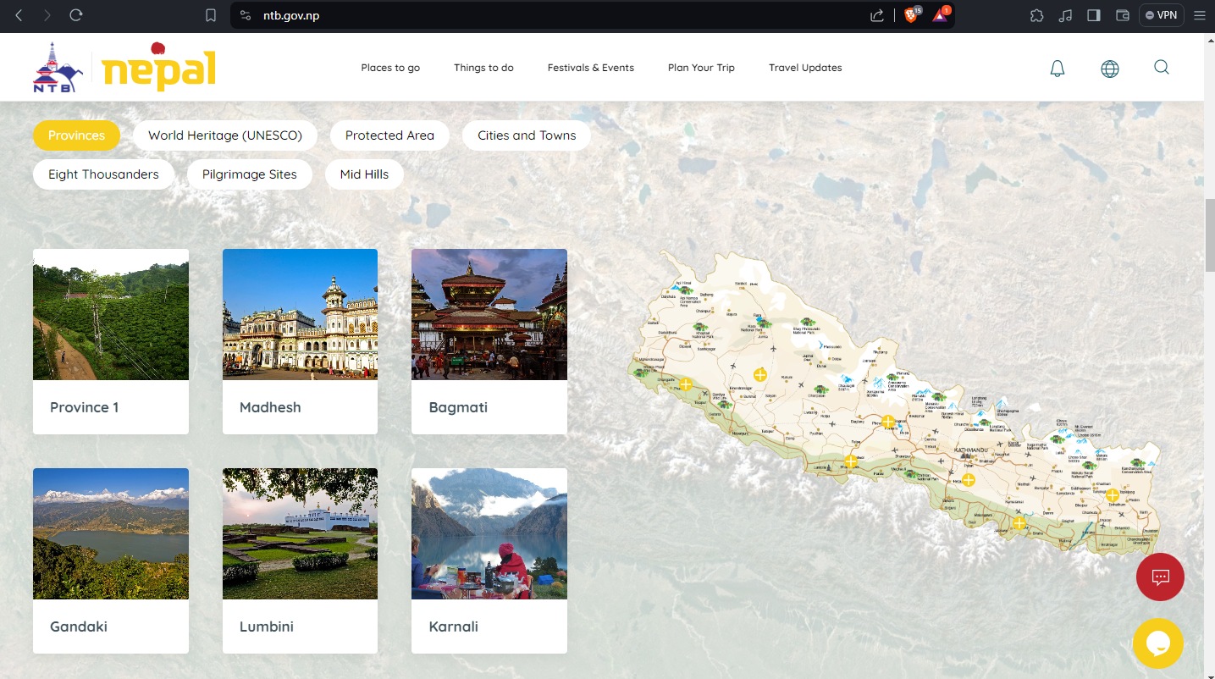

1. User control and freedom

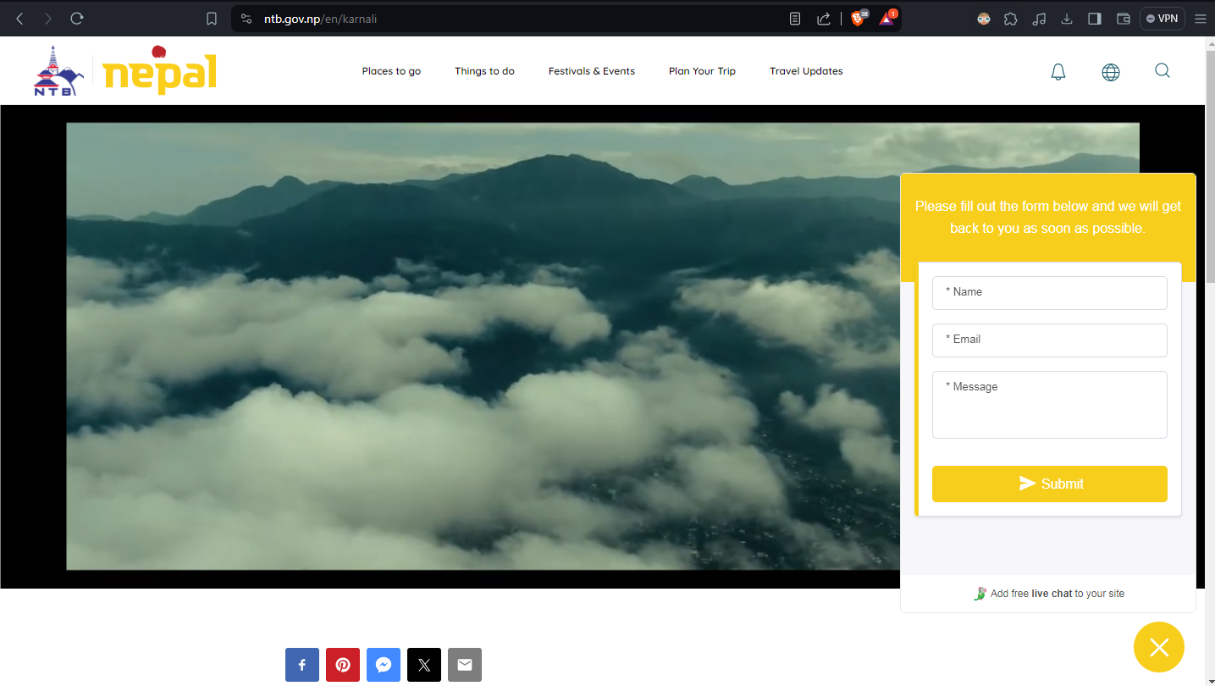

1. Consistency and standards
2. Error prevention

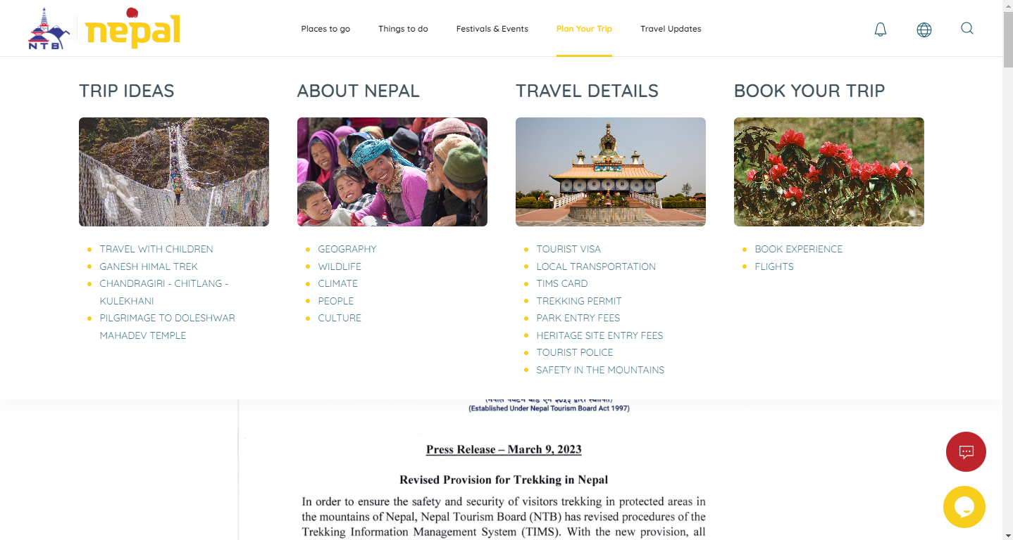

1. . Recognition rather than recall

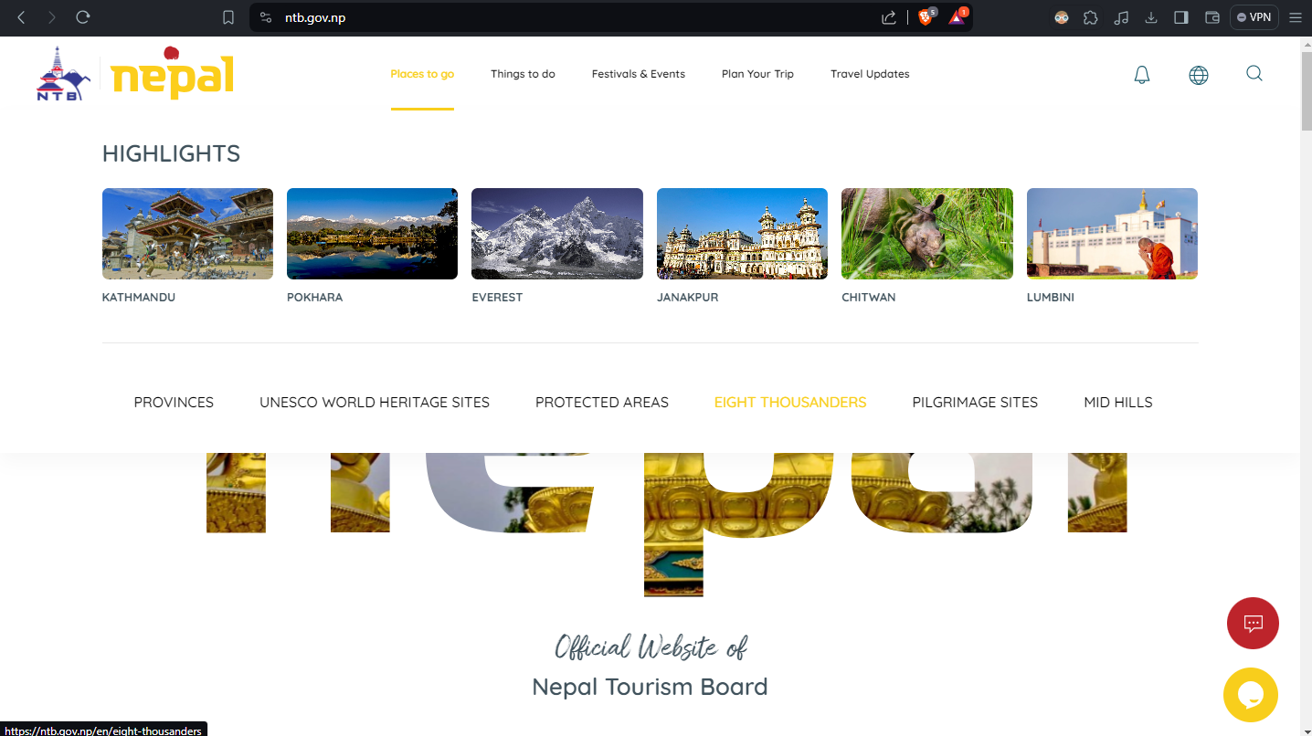

1. Flexibility and efficiency of use

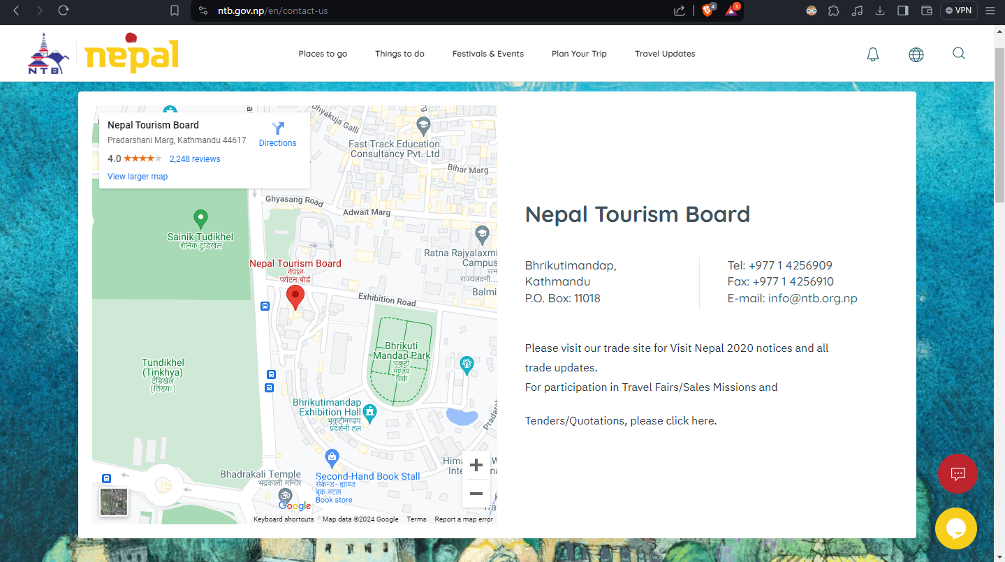

1. Aesthetic and minimalist design



1. Help users recognize, diagnose, and recover from errors

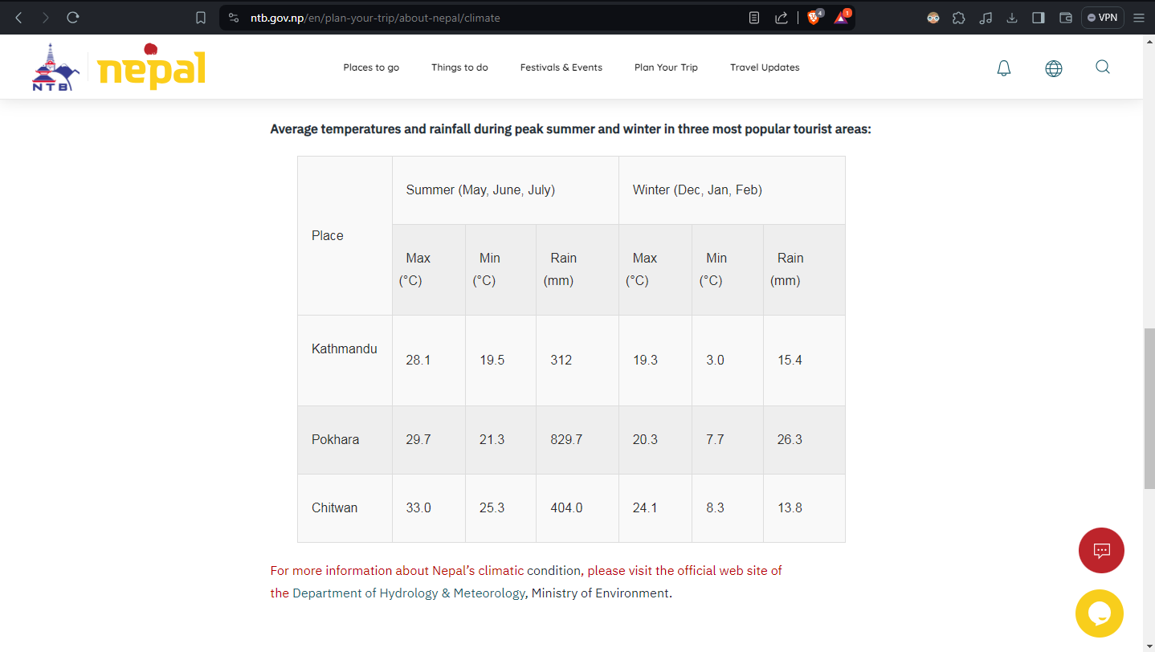

1. Help and documentation

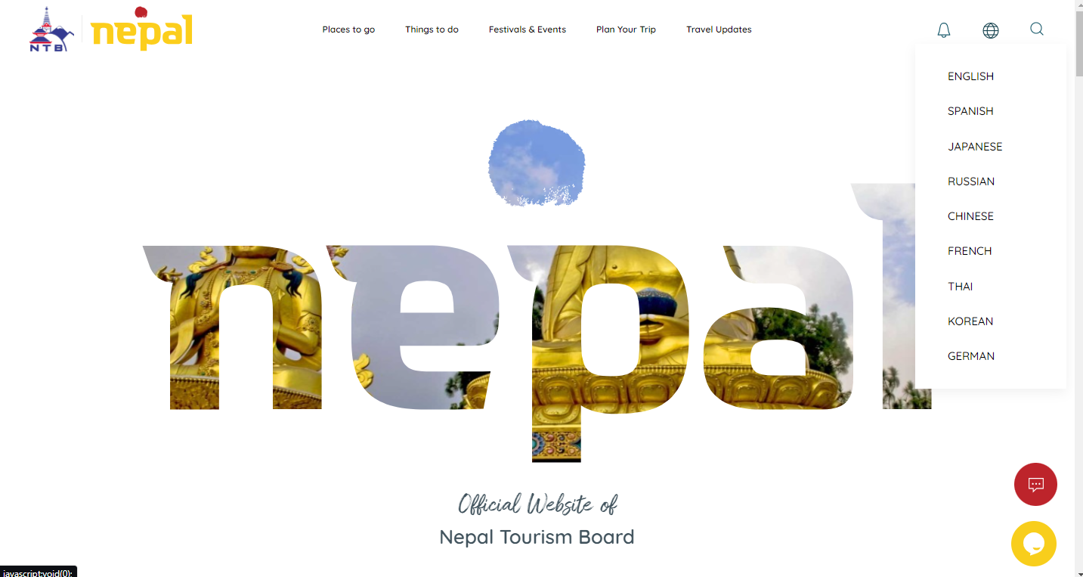

1. [**https://dnpwc.gov.np/en/**](https://dnpwc.gov.np/en/) **:**

“Schneider man’s 8 golden rules”

1. Strive for consistency

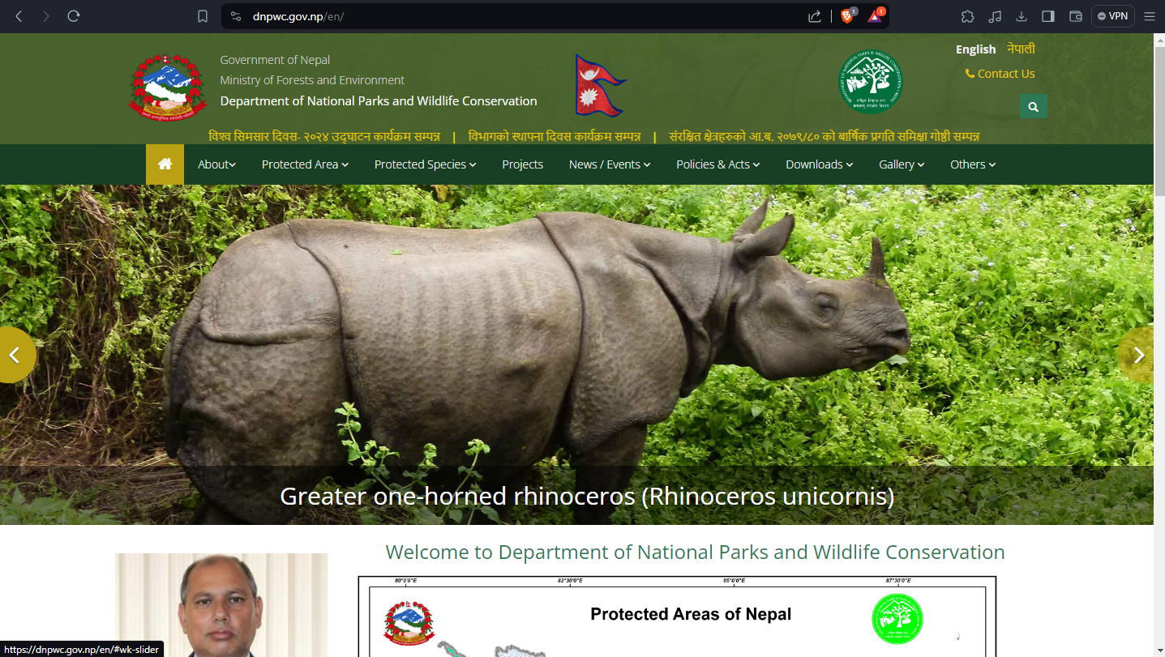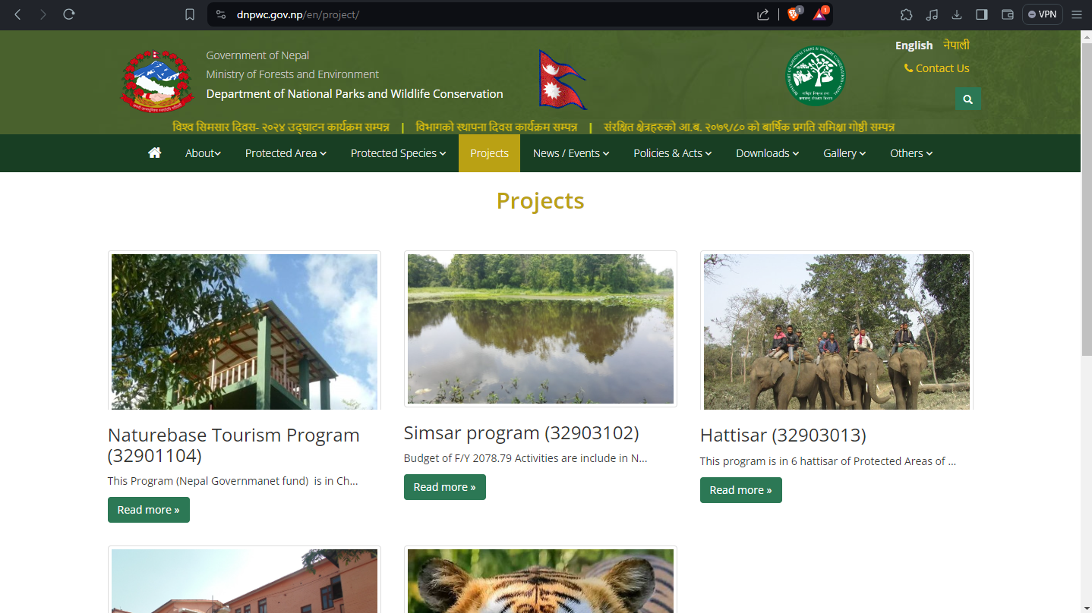

1. Enable frequent users to use shortcuts

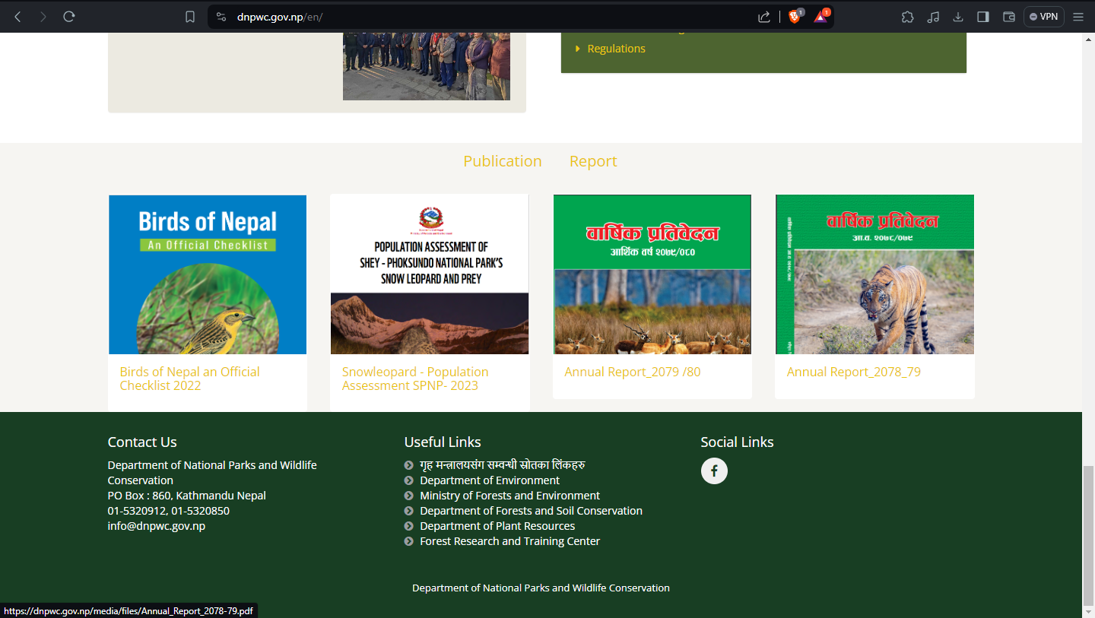

1. Offer informative Feedback

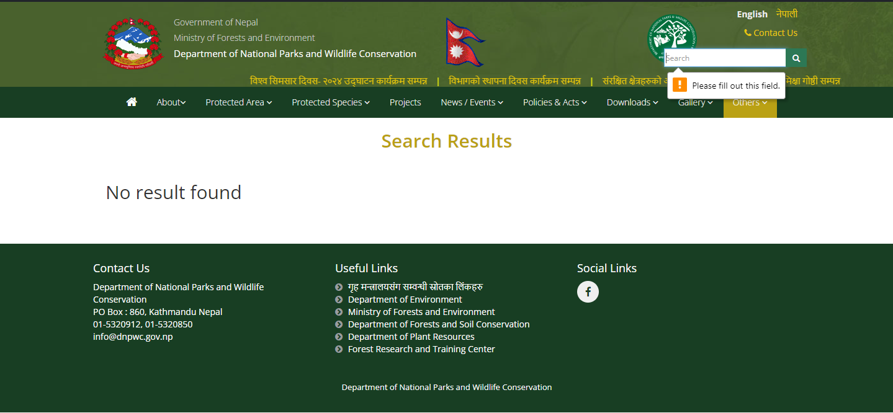

1. Design dialog to yield closure

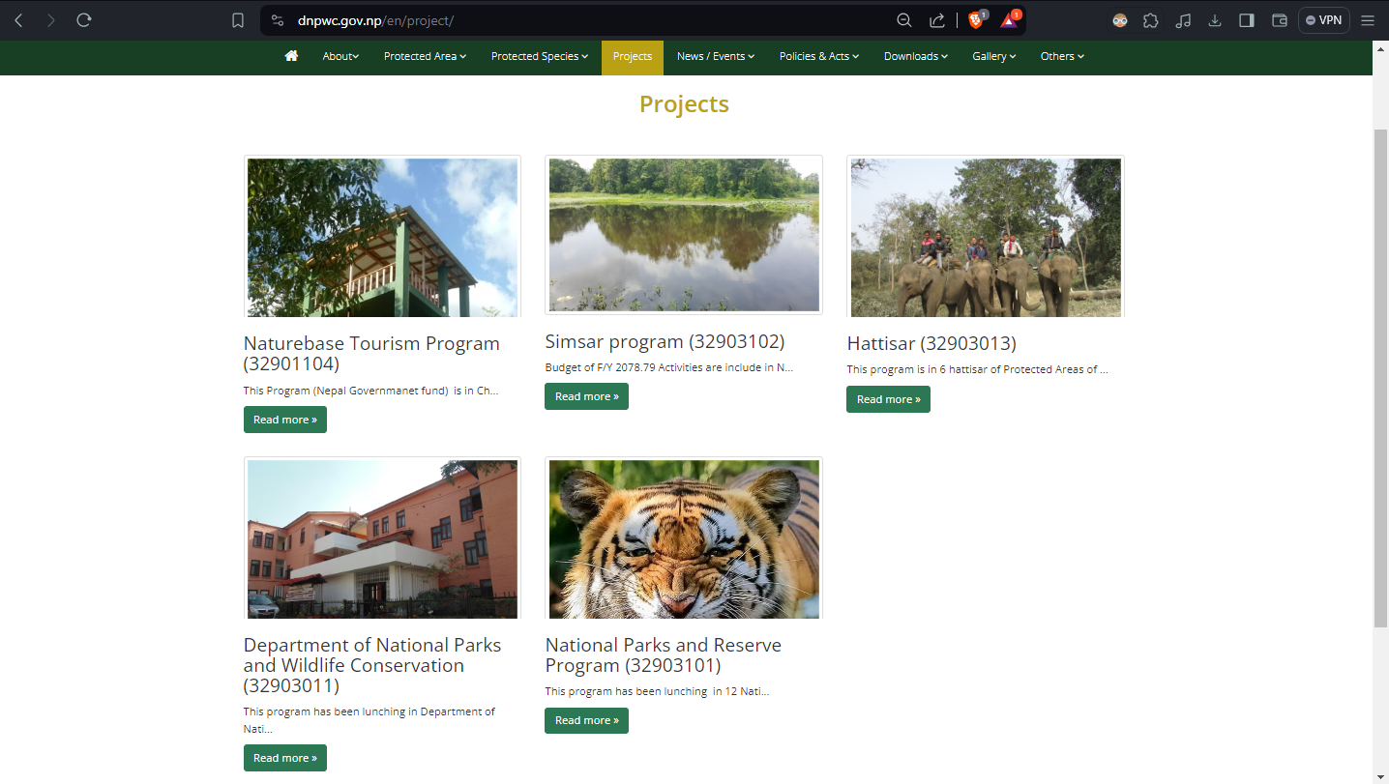

1. Offer simple error handling

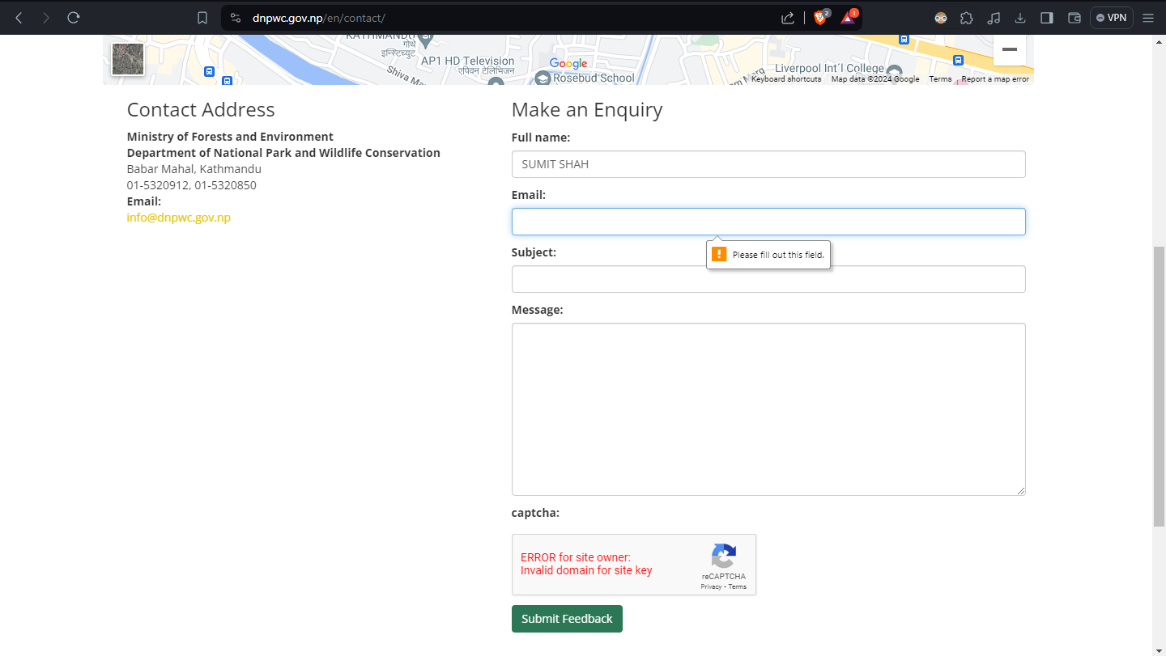

1. Permit easy reversal of actions

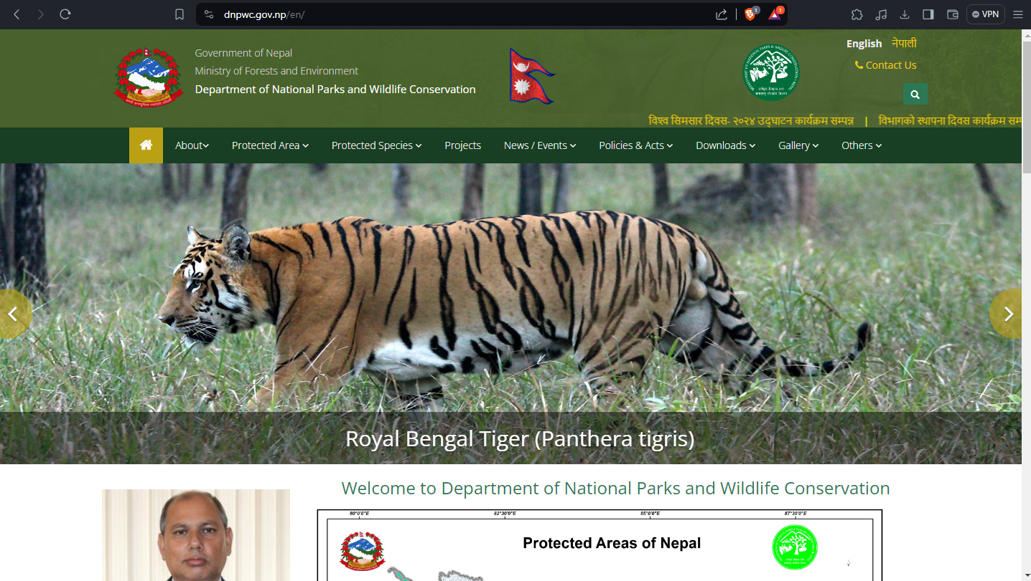

1. Support internal locus of control

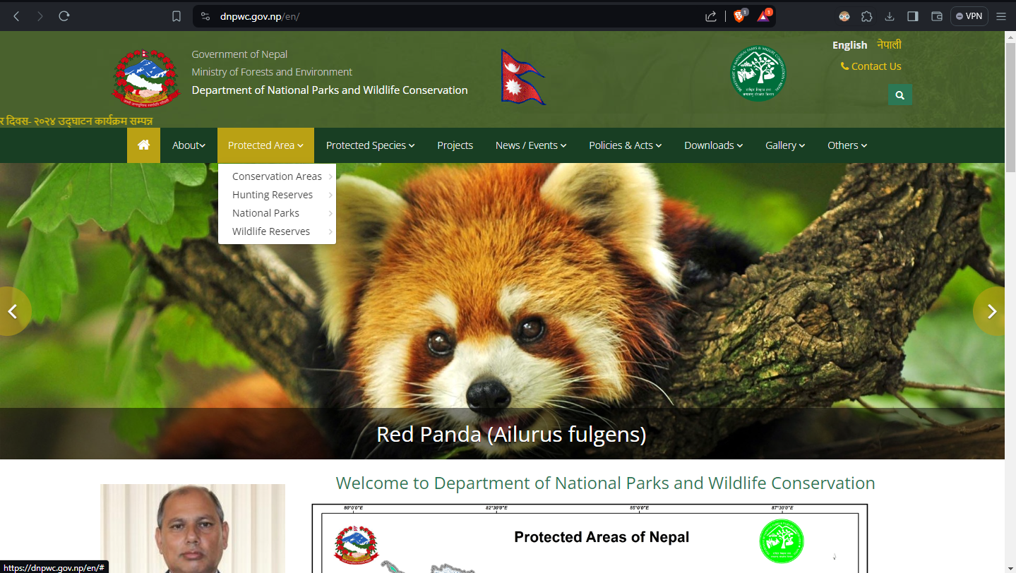

1. Reduce short-term memory load

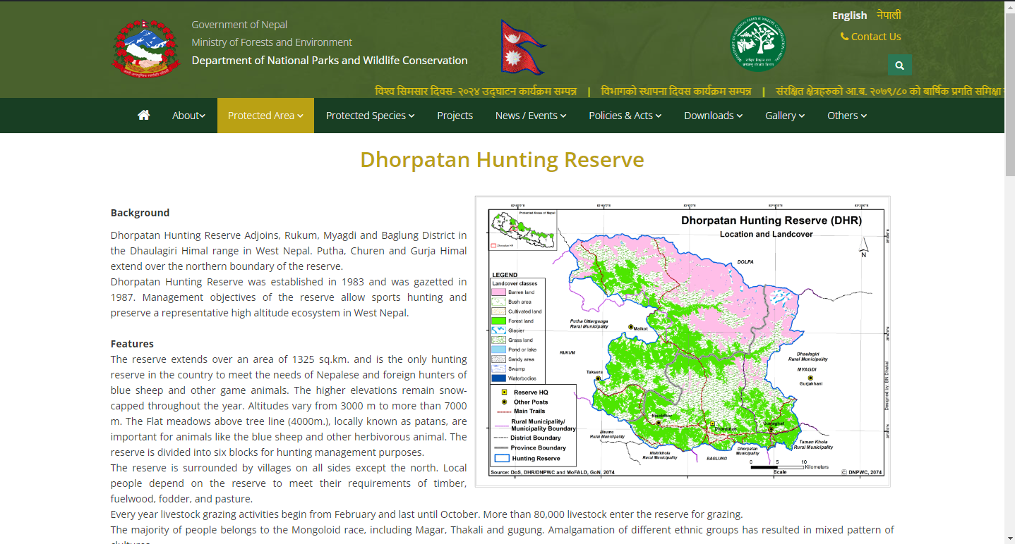

“Nielson’s Usability Heuristics”

1. Visibility of system status

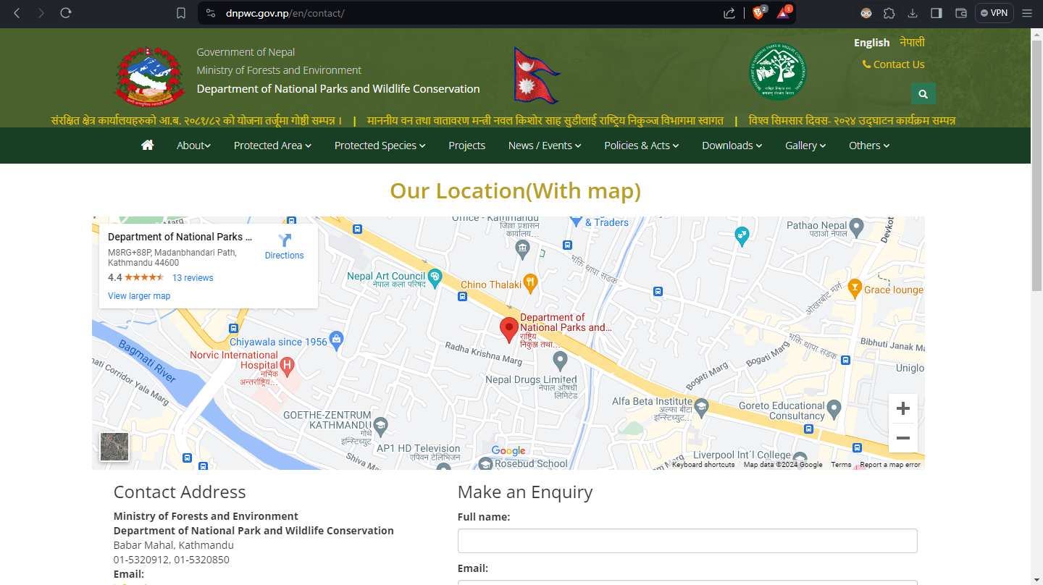

1. Match between system and the real world

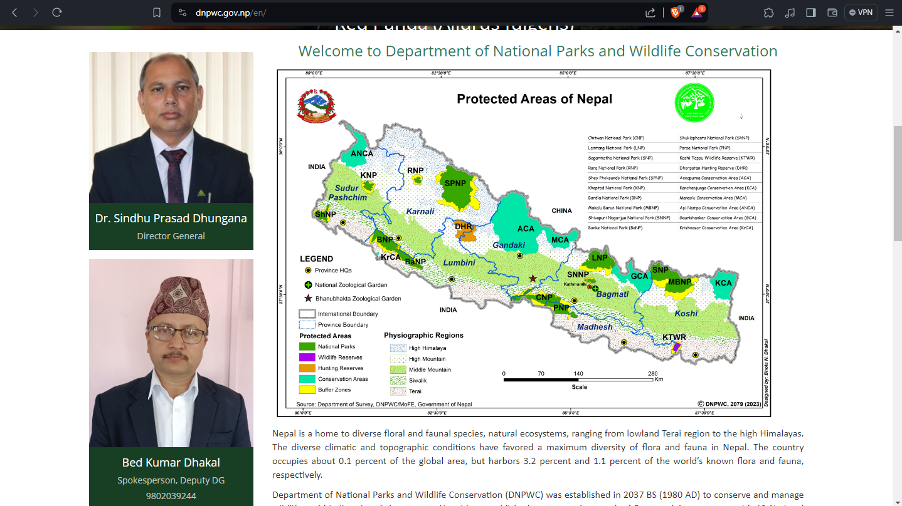

1. User control and freedom

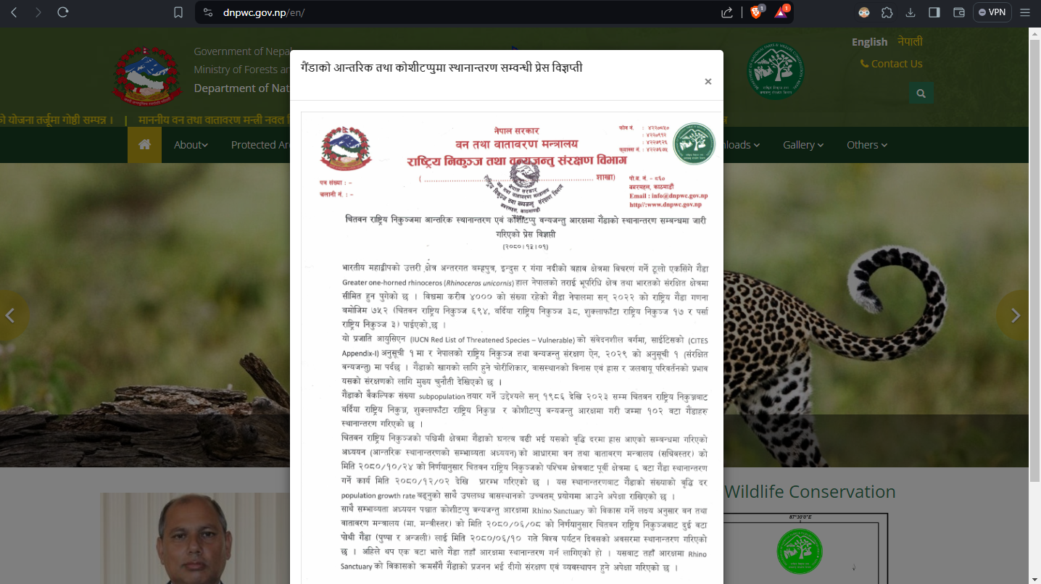

1. Consistency and standards
2. Error prevention

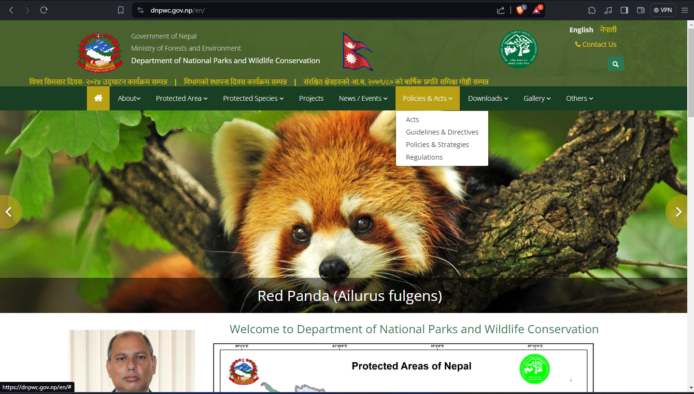

1. Recognition rather than recall

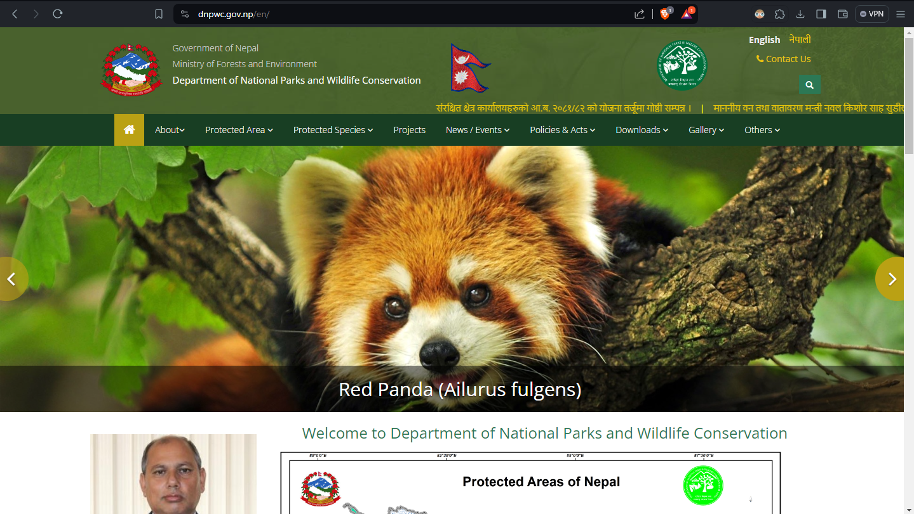

1. Flexibility and efficiency of use
2. Aesthetic and minimalist design

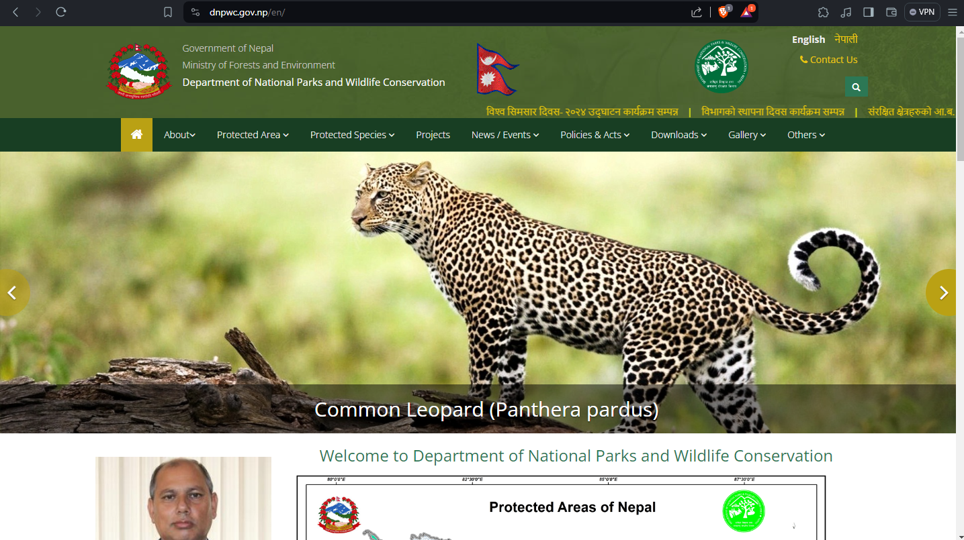

1. Help users recognize, diagnose, and recover from errors

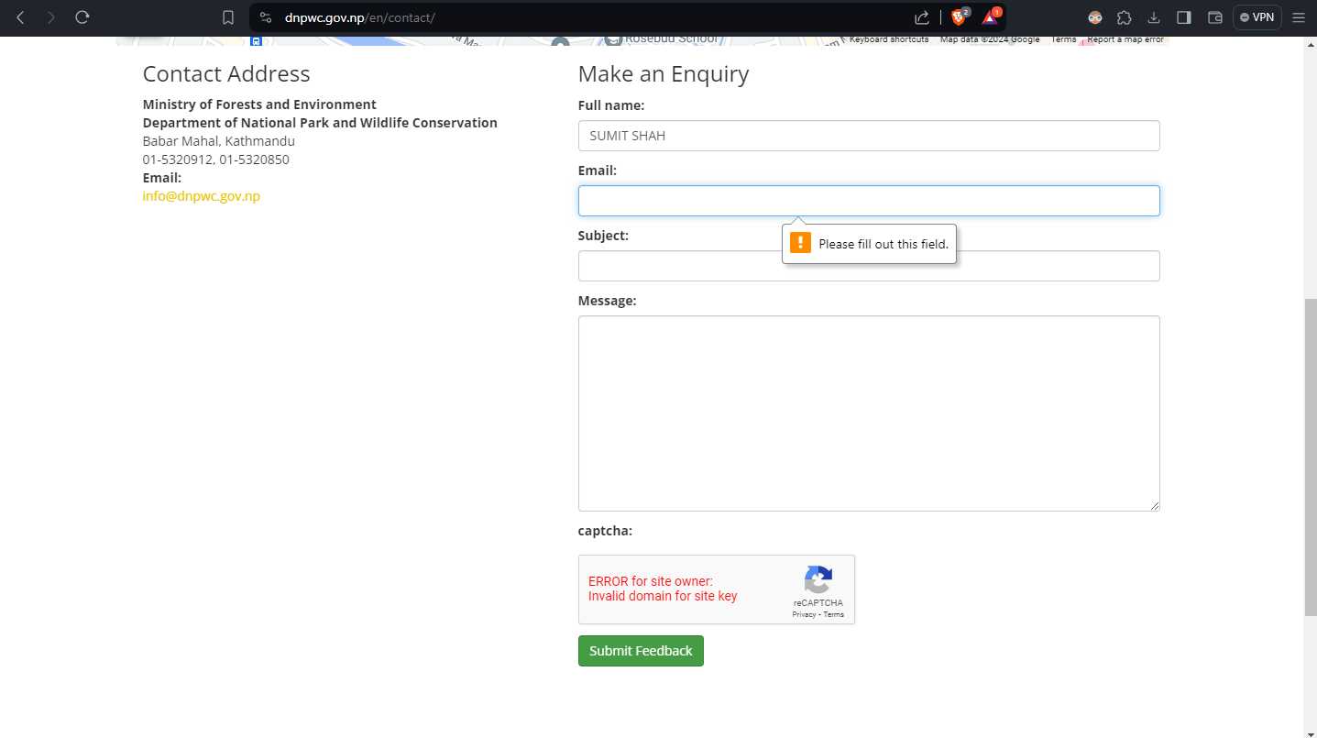

1. Help and documentation

